Alison Wem offers a new approach to managing stress and anxiety in our 21st-century lives. Finding Your Soul Family provides you with techniques to help you know yourself better and to enhance your sense of personal calmness so you can be more effective at work and live more harmoniously at home.
Part 1 has easy-to-follow exercises to gain insight into yourself
Part 2 discusses whether you get multiple opportunities to learn Life Lessons. Perhaps we bring into this life the Life Lessons we have previously learnt – and along with them some poor habits as well
‘This book offers fun and revealing exercises for getting to know your inner self and to understand better your spiritual path.’
Nigel Peace, owner of Local Legend publishing and nominated by Kindred Spirit magazine as MBS Personality of the Year
Alison lives and works in Kensington, London. She runs workshops using this book as a reference guide, presents at the College of Psychic Studies, South Kensington & The London Spiritual Mission, Notting Hill, writes a blog and is active on Facebook and Twitter. www.yoursoulfamily.com
Book Images
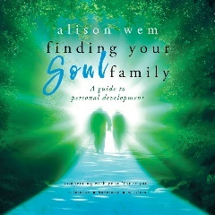
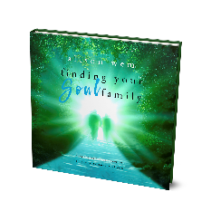
Launch date: 11th February 2019 Price: £17.95
ISBN: 978-1-9997014-3-7 Format: print
Publisher on Neilsen
Distributor: IngramSpark (in the UK Lightning Source)
Headshots

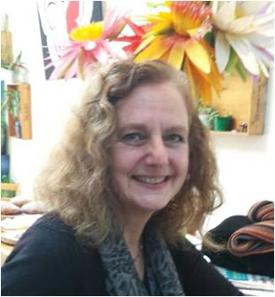
Alison Wem

Contact: 07966 137568
Alison.wem@yoursoulfamily.com

Short Bio

Alison Wem is married with five grownup children who have all flown the nest. After a busy career, she has only recently taken up writing to share how she moved forward from widowhood through soul art to find an inner strength and wisdom she did not know she possessed.
Creating Your Soul Map - First Book in the Your Soul Family Series

